Southern Ontario DVD Pool
June 2019
Delivery instructions

While a few libraries might find it more convenient to drive the blocks of DVD materials to the next library, there is enough surplus funds (from a very long time ago), that we can use the Government rate Purolator account. Rather than having everyone use their own account– and then bill Hastings Highlands, we ask that you follow these instructions to use the Purolator account for Hastings Highlands Library.
You can ship by whatever means you wish – and often the “fillable forms” from Purolator are the easiest to use.
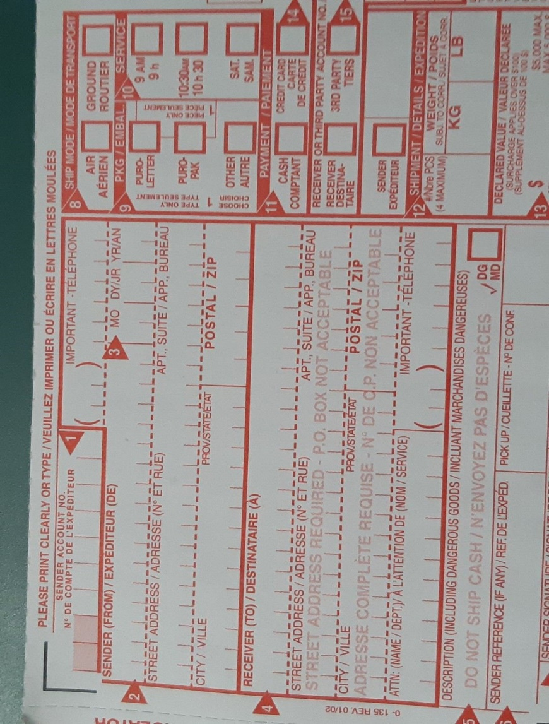
Enter the information for sender (you) and then receiver (the library receiving your block).
Where it says Payment – enter the Purolator account for Hastings Highlands Library – 4861736
Please remember that this Purolator account is only to be used for shipping of materials in the Southern Ontario DVD pool.

We are definitely encouraging all libraries to register for a Government rate Purolator account – with specific details posted on the SOLS website at https://www.sols.org/index.php/other-collective-purchasing-options. At that page, you want “Province of Ontario Vendors of Record”
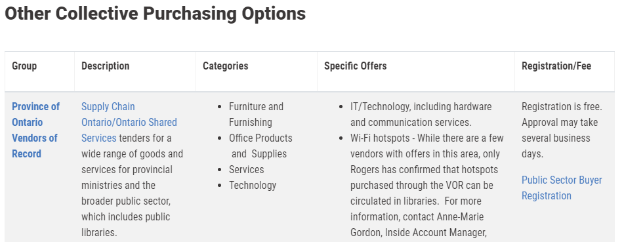

According to our records, the following libraries within the Southern Ontario DVD pool already have accounts (which were set up around 2013)–
- Alderville
- Bancroft
- Barry’s Bay/Madawaska Valley
- Beausoleil
- Bradford
- Gravenhurst
- Greater Madawaska
- Tyendinaga Township
- Wollaston

Another option is to use the on-line shipping tool – which you will find at https://eshiponline.purolator.com/ShipOnline/Welcome.aspx

You have to sign-in – but then you would again, for payment, you would use the Hastings Highlands number (as described on the next page)
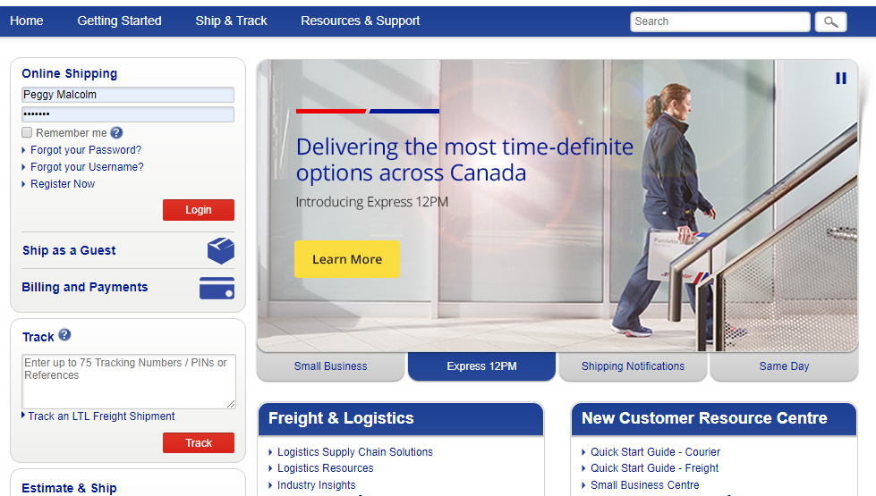

When using this online tool, the first step is to “create a shipment”.
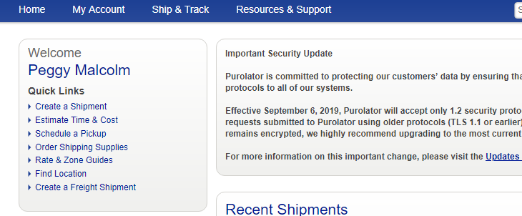
Once you select that option your screen will look something like this
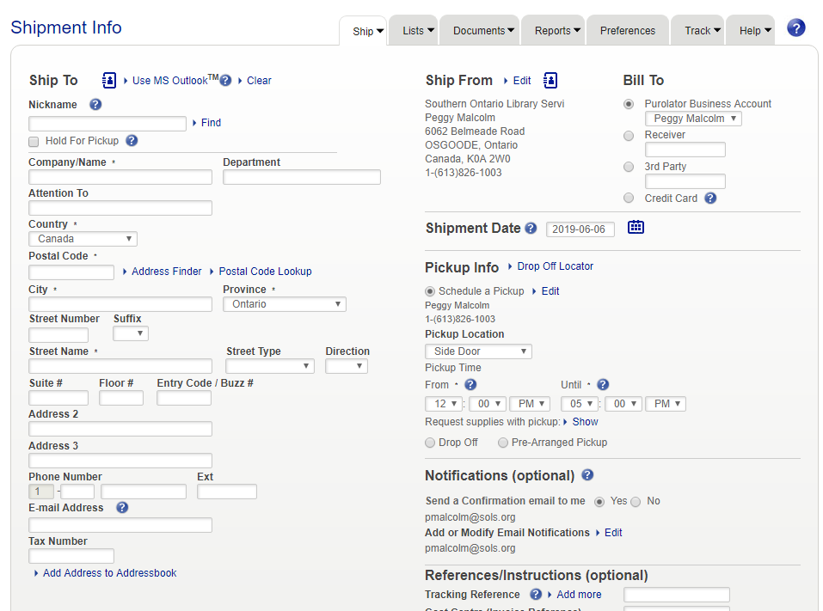

You will need to fill in the “Ship-to” information – which you will have off of the rotation sheet.
If you do not have an account already (or are not registered), you will have to edit to “Ship From” information – so that the Purolator folks know where to pick up your materials.
In the “Bill-to” section – you will select the button for “3rd party” – this means that you are telling Purolator that you are using another library’s Purolator account. In this case, you will enter the account number 4861736 – this is the account for Hastings Highlands Library.
Please remember that this Purolator account is only to be used for shipping of materials in the Southern Ontario DVD pool.

From that point, you complete the information requested – and after saying “ship now” – you will be able to print a shipping label – one label is required for each box (so be sure to write in 2 or 3 or 4 where it says “Number of items” – as this will generate the labels for each box).

